HW#1

1. Find the two’s complement representation for the following numbers, assuming they are represented as a 16-bit number. Write the value in both binary and hexadecimal. _ _ _ _ - _ _ _ _ - _ _ _ _- _ _ _ _ (my template for 16 bit number.
2. –93

93 – 26 = 29- 24 = 13 – 23 = 5 – 22 = 1- 20 = 0

_ _ _ _ - _ _ _ _ - _ 1 _ 1 - 1 1 _ 1

0000 0000 0101 1101 = 93

Now two’s comp because negative

1111 1111 1010 0011 = -93

F F A 3 -> 0xFFA3

1. 1034

1034 – 2^10 = 10 – 2^3 = 2 – 2^1 = 0

_ _ _ _ - _ 1 _ _ - _ _ _ _- 1 _ 1 _

0000 0100 0000 1010 = 1034, this is the two’s complement representation since it is positive.

0x040A -> 0x40A

1. 492

492-2^8 = 236-2^7 = 108 – 2^6 = 44 – 2^5 = 12 – 2^3 = 4 -2^2 = 0

_ _ _ _ - _ _ _ 1 - 1 1 1 _- 1 1 _ _

0000 0001 1110 1100 = 492 ‘s 2’s complement representation

Hex = 0x1EC

1. –1094

1094 – 2^10 = 70 – 2^6 = 6 – 2^2 = 2 -2^1 = 0

_ _ _ _ - _ 1 _ _ - _ 1 _ _- _ 1 1_

0000 0100 0100 0110 = 1094

Two’s comp

1111 1011 1011 1010 = -1094

Hex = 0xFBBA

1. Convert the following binary values into hexadecimal:
2. 10 0010 1010 1111

2 2 A F

0x22AF

1. 10 1011 1000 0110

2 B 8 6

0x2B86

1. 1011 1010 1011 1110

B A B E

0xBABE

1. 1111 1010 1100 1110

F A C E

0xFACE

1. Convert the following hexadecimal values to base ten:
2. 0xFE98

(15)16^3+(14)16^2+(9)16^1+(8)16^0

61440 + 3584 + 144 + 8 = 65176

1. 0xFEED

(15)16^3+(14)16^2+(14)16^1+(13)16^0

61440 + 3584 + 224 + 13 = 65261

1. 0xB00

(11)16^2+(0)16^1+(0)16^0

2816

1. 0xDEAF

(13)16^3+(14)16^2+(10)16^1+(15)16^0

53248 + 3584 + 160 + 15 = 57007

1. Convert the following base ten numbers to base four:

4^5 = 1024 4^4 = 256 4^3 = 64 4^2 = 16

1. 812

812/256 = 3 r(44) 44/16 = 2 r(12) 12/4 = 3

302304

1. 101

101/64 = 1 r(37) 37/16 = 2 r(5) 5/4 = 1 R(1) 1/1 = 1

12114

1. 96

96/64 = 1 r(32) 32/16 = 2

12004

1. 3640

3640/1024 = 3 r(568) 568/256 = 2 r(56) 56/16 = 3 r(8) 8/4 = 2

3203204

1. Convert the following decimal numbers into hexadecimal:

16^3 = 4096 16^2 = 256 16^1 = 16 16^0 = 1

1. 256

256/256 = 1

0x100

1. 1000

1000/256 = 3 r(232) 232/16 = 14 r(8) 8/1 = 8

0x3E8

1. 4095

4096 = 0x1000 4096 – 1 = 4095 0x1000-0x1 = 4095

0x0FFF

1. 42

42/16 = 2 r(10) 10/1 = 10

0x2A

1. Multiply the following binary values. Notice that binary multiplication works exactly like decimal multiplication, except you are either adding 0 to the final product or a scaled multiplicand. For example:

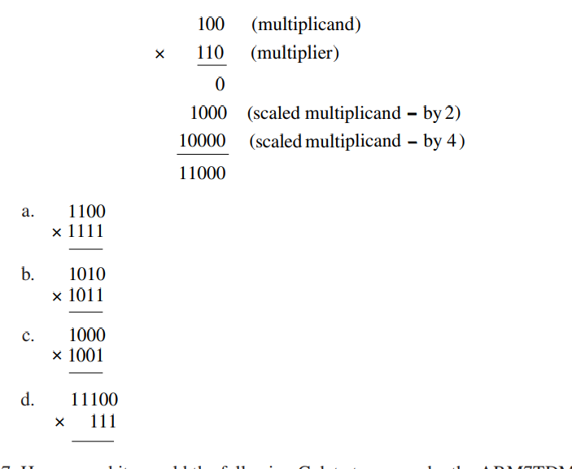

|  |  |  |  |  |  |  |  |  |
| --- | --- | --- | --- | --- | --- | --- | --- | --- |
|  |  |  |  |  | 1 | 1 | 0 | 0 |
|  |  |  |  | x | 1 | 1 | 1 | 1 |
|  | 1 | 1 | 1 | 1 | 1 | 1 | 0 | 0 |
|  |  |  |  | 1 | 1 | 0 | 0 |  |
|  |  |  | 1 | 1 | 0 | 0 |  |  |
|  |  | 1 | 1 | 0 | 0 |  |  |  |
|  | 1 | 0 | 1 | 1 | 0 | 1 | 0 | 0 |

|  |  |  |  |  |  |  |  |  |
| --- | --- | --- | --- | --- | --- | --- | --- | --- |
|  |  |  |  |  | 1 | 0 | 1 | 0 |
|  |  |  |  | x | 1 | 0 | 1 | 1 |
|  |  |  | 1 |  | 1 | 0 | 1 | 0 |
|  |  |  |  | 1 | 0 | 1 | 0 |  |
|  |  |  | 0 | 0 | 0 | 0 |  |  |
|  |  | 1 | 0 | 1 | 0 |  |  |  |
|  |  | 1 | 1 | 0 | 1 | 1 | 1 | 0 |

|  |  |  |  |  |  |  |  |  |
| --- | --- | --- | --- | --- | --- | --- | --- | --- |
|  |  |  |  |  | 1 | 0 | 0 | 0 |
|  |  |  |  | x | 1 | 0 | 0 | 1 |
|  |  |  |  |  | 1 | 0 | 0 | 0 |
|  |  |  |  | 0 | 0 | 0 | 0 |  |
|  |  |  | 0 | 0 | 0 | 0 |  |  |
|  |  | 1 | 0 | 0 | 0 |  |  |  |
|  |  | 1 | 0 | 0 | 1 | 0 | 0 | 0 |

|  |  |  |  |  |  |  |  |  |
| --- | --- | --- | --- | --- | --- | --- | --- | --- |
|  |  |  |  | 1 | 1 | 1 | 0 | 0 |
|  |  |  |  | x |  | 1 | 1 | 1 |
| r | 1 | 1+1 | 0 | 1 |  |  |  |  |
|  |  |  |  | 1 | 1 | 1 | 0 | 0 |
|  |  |  | 1 | 1 | 1 | 0 | 0 |  |
|  |  | 1 | 1 | 1 | 0 | 0 |  |  |